# R10922123 周昱豪

# Code:

1. 產生Gaussian noise and Salt-and-Pepper 的code  
   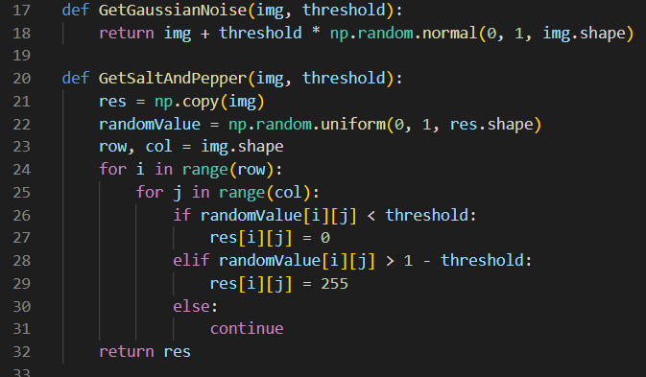
2. Box filter and Median filter: 基本上都是跟著PPT上做  
   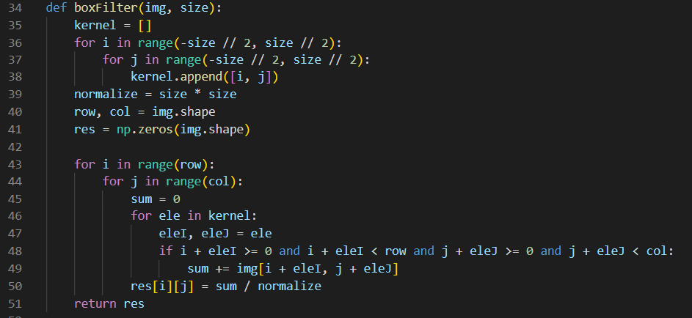

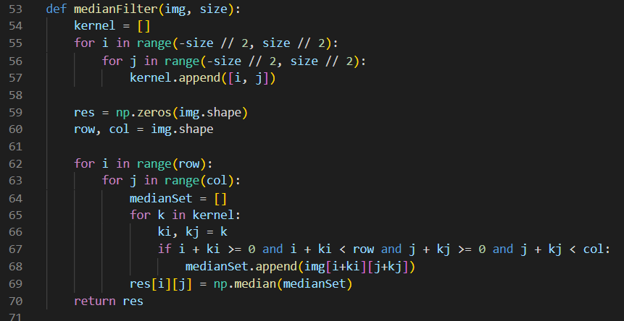

1. SNR及各個結果跑出來的結果: 跟著投影片做，一開始先除255做normalize不然會overflow.

|  |  |
| --- | --- |
|  |  |

# Result:

1. Gaussian noise with threshold 10與他們被filter弄出來後的結果

|  |  |
| --- | --- |
| C:\Users\naive\AppData\Local\Microsoft\Windows\INetCache\Content.Word\gaussianImage_10.bmp  Gaussian noise with threshold 10, SNR = 13.586684135545916 | |
| Box filter 3x3, SNR = 11.111537202059152 | Box filter 5x5, SNR = 11.226577570238167 |
| Median filter 3x3, SNR = 11.38268222171413 | Median filter 5x5, SNR = 11.85053943159046 |
| Closing-then-Opening, SNR = 13.589686807035338 | Opening-then-Closing, SNR = 13.271450007185388 |

1. Gaussian noise with threshold 30

|  |  |
| --- | --- |
| Gaussian noise with threshold 30, SNR = 4.060634967276163 | |
| Box filter 3x3, SNR = 9.381058312765244 | Box filter 5x5, SNR = 10.507167192147811 |
| Median filter 3x3, SNR = 8.963151133255158 | Median filter 5x5, SNR = 10.74985212490406 |
| Closing-then-Opening, SNR = 11.117000794482175 | Opening-then-Closing, SNR = 11.172346418330017 |

1. Salt-and-Pepper with probability 0.05

|  |  |
| --- | --- |
| Salt-and-Pepper with probability 0.05, SNR = 0.9109636739377763 | |
| Box filter 3x3, SNR = 7.747552096737459 | Box filter 5x5, SNR = 9.354122103564995 |
| Median filter 3x3, SNR = 11.527530775181132 | Median filter 5x5, SNR = 11.83658559544174 |
| Closing-then-Opening, SNR = 5.49777282451031 | Opening-then-Closing, SNR = 5.7638790575066645 |

1. Salt-and-Pepper with probability 0.1

|  |  |
| --- | --- |
| Salt-and-Pepper with probability 0.1, SNR = -2.072483710069579 | |
| Box filter 3x3, SNR = 5.525907019306557 | Box filter 5x5, SNR = 7.546649625596008 |
| Median filter 3x3, SNR = 10.536956872650471 | Median filter 5x5, SNR = 11.73739453542163 |
| Closing-then-Opening, SNR = -2.447931602576144 | Opening-then-Closing, SNR = -2.056008954060036 |